RESOLUTIONS REACHED DURING CM's MEETING WITH REPRESENTATIVES OF DRIVING SCHOOL ASSOCIATIONS ON 21 ^{st} AUGUST 2020
- To ensure funding, Driving Schools are encouraged to take advantage of Federal Government SMEs loans.
- The Corps will only increase slot for driving schools that comply with the requirements and guidelines.
- Driving schools to be re-categorized based on their capacity for training of applicants for driver's licence including class 'A' drivers licence.
- Only driving schools that have the capacity to train motorcycle and tricycle riders and have been re-categorized as such shall be allowed to train and issue certificate to applicant for class 'A' drivers licence.
- The three (3) Associations (NDSPA, ADIN, and DSAN) are encouraged to close ranks by working as a team to forge a common front for the promotion of quality driver training and safety on Nigeria roads.
- The three (3) Associations (NDSPA, ADIN, and DSAN) shall meet quarterly to discuss issues of Mutual interest and present a common representative for inclusion in I-wc, NRSS.
- Representatives of the Three (3) Associations (NDSPA, ADIN, and DSAN) shall form part of the State Committee for inspection of new driving schools for certification.
- A Technical Committee to be chaired by the DCM Training with two (2) representatives from each of the three (3) Associations shall be set up to meet to review the standards and criteria for Driving School Operations and allied matters with report to be submitted.
- A Monitoring and Evaluation (M&E) unit shall be set up by the three (3) Associations in each state and FCT to monitor activities while the Corps shall carry out periodic audits to ensure that the activities of Driving Schools conform with set standards and legal requirements.
- The Code of Conduct endorsed by members of the three (3) Associations shall be updated from time to time to reflect current trends with respect to their activities.
- The DSSP programmer should ensure that applicant's picture reflect on the certificate generated via CBT at the completion of the 26th training session.
12. Interested Driving Schools shall put in place appropriate machinery for the training of motorcycle and tricycle riders.
  - The Driving Schools Associations are encouraged to promote Articulated o vehicle wings in their various member driving schools.
  - The payment for generation of certificate shall be five hundred naira (N500) only for motor vehicles and two hundred naira (N200) only for motorcycles and tricycles.
  - The fee payable for renewal of instructor's certificate shall be determined by the technical committee.
  - Training of Driving School Operators and Instructors on CBT, Articulated vehicles and Motorcycles/Tricycles to be held at a time to be determined by the Technical Committee before the end of year 2020.
  - Operators Guide to be sent to representatives of the three (3) Driving School Associations for inputs on or before Tuesday 24 August, 2020.
  - The three (3) Associations (NDSPA, ADIN, and DSAN) shall meet quarterly with FRSC to discuss issues of Mutual interest.

NDSPA NATIONAL PRESIDENT NbSPA NATIONAL SECRETARY
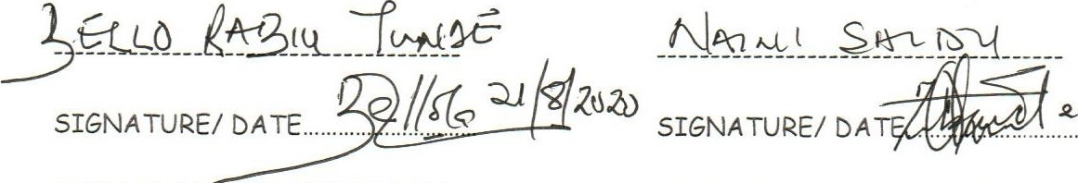z 1 2b

AblN NATIONAL PRESIDENT ADIN NATIONAL SECRETARY
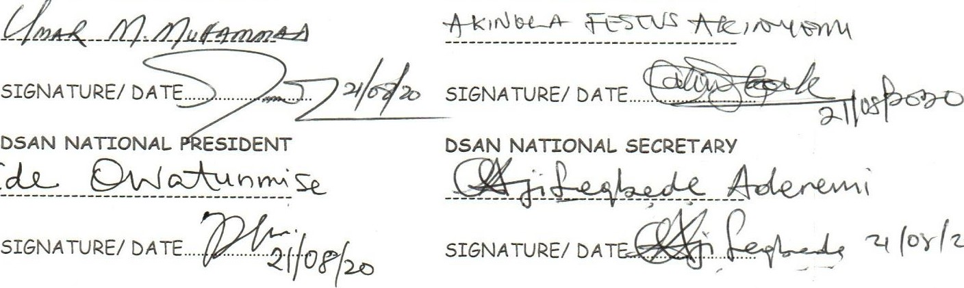
TC_u-L
DEPUTY CORPS MARSHAL TRAINING
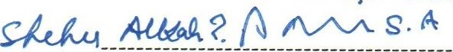
SIGNATURE-DATE.

FRSC, DRIVING SCHOOL ASSOCIATION ADOPTS RESOLUTIONS ON ROAD SAFETY AND TRAINING OF DRIVERS

One of the aims and objectives of the FRSC is to ensure road safety and quality drivers on the road. And to avoid road crashes and hitches, The Federal Road Safety Corps (FRSC) and Driving School Associations (DSA) have adopted resolutions towards promotion of quality driver training and ensuring safety on Nigeria roads.

The Corps Marshal, Dr Boboye Oyeyemi, and representatives of Driving School Associations (DSA) gave these resolutions at the meeting held on Friday in Abuja.

According to the Corps Public Education Officer, (CPEO) Mr Bisi Kazeem, The associations that attended the meeting includes Nigeria Driving School Proprietors Association (NDSPA) (ADIN) And Driving School Association of Nigeria (DSAN).

"The three associations were encouraged to close ranks by working as a team to forge a common front for the development of quality driver training and safety on the roads.

"Interested Driving Schools shall put in place appropriate machinery for the training of motorcycle and tricycle riders.

"Driving schools to be re-categorized based on their capacity for training of applicants for driver's licence including class 'A' drivers licence.

"Only driving schools that have the capacity to train motorcycle and tricycle riders and have been re-categorized as such shall be allowed to train and issue certificate to applicant for class 'A' drivers licence," it stated.

The Statement said that a technical Committee to be chaired by the DCM Training with two (2) representatives from each of the three (3) Associations shall be set up to meet to review the standards and criteria for Driving School Operations and allied matters with report to be submitted.

Kazeems said that according to the agreement reached, Representatives of the Three (3) Associations (NDSPA, ADIN, and DSAN) shall form part of the State Committee for inspection of new driving schools for certification.

The statement said the payment for generation of certificate shall be five hundred naira (N500) only for motor vehicles and two hundred naira (N200) only for motorcycles and tricycles adding that the fee payable for renewal of instructor's certificate shall be determined by the technical committee.

"A Monitoring and Evaluation (M&E) unit shall be set up by the three associations in each state and FCT to monitor activities while the Corps shall carry out periodic audits to ensure that the activities of Driving Schools conform with set standards and legal requirements, " it stated.

According to the agreement, DSAs are encouraged to promote articulated of vehicle wings in their various member driving schools.

In the same vien, the statement said that to ensure funding, Driving Schools are encouraged to take advantage of Federal Government SMEs loans stating that the Corps will only increase slot for driving schools that comply with the requirements and guidelines.

Present at the meeting are National President, NDSPA, Mr Bello Rabiu Tunde, National Secretary, NDSPA, Mr Naini Saidu, National President, ADIN, Mr Umar M. Muhammad,
National Secretary, ADIN, Mr Akinola Festus Akinyomi.

National President, DSAN, Mr Jide Owatunmishe, National Secretary, DSAN, Mr Ajisegbede Aderemi and on FRSC's side Dr Boboye OYEYEMI led the team with
Deputy Corps Marshal, Training, DCM, Shehu.
Assistant Corps Marshal Ann Marjah, Corps Legal Adviser and Assistant Corps Marshal Bisi Kazeem, Corps Public Education Officer also in attendance.

